

ICIS-NPDES Unpermitted Facility Plug-In Starter Kit

Installation and Administration Guide

EN-Node

Version: 1.0

January 19, 2012

Logo

1368 How Lane

North Brunswick, New Jersey 08902

[www.enfotech.com](http://www.enfotech.com)

Restriction on Use and Disclosure of Document Information

This document includes data that should not be disclosed outside the business entity for which it was intended, indicated as the recipient on this title page. The entire document is copyrighted by enfoTech and is protected under the US copyright law and international treaties. No part of this document may be reproduced or transmitted in any form or by any means, electronic or mechanical, for any purpose, without express written permission from enfoTech & Consulting Inc.

Copyright © 2001 – 2010 by enfoTech & Consulting Inc. All Rights Reserved.

Revision History

|  |  |  |  |  |
| --- | --- | --- | --- | --- |
| Version | Date | Created By | Reviewed By | Description |
| 1.0 | 01/19/2012 | Charlie Zhang |  |  |
|  |  |  |  |  |
|  |  |  |  |  |
|  |  |  |  |  |

Tables of Contents

1. Document Purpose 4

2. Plug-In Overview 4

3. Supported Schemas and Payloads 5

4. Prerequisites 5

5. Installation Package 5

6. Installation Instruction 5

6.1 Create a ICIS-NPDES Unpermitted Facility staging database 5

6.2 Modify DataWizardConfig_UnpermitedFacility.xml 6

6.3 Create a ICIS Domain in the Node Administration Console 6

6.4 Create a submit web service with the ICIS_Unpermitted_Facility plug-in 7

6.5 Configure ICIS_Unpermitted_Facility plug-in for Operation Manager 9

7. Test ICIS-NPDES Unpermitted Facility Plug-In 11

7.1 Obtain Status and Supplied Transaction ID 11

7.2 Retrieving and Downloading file from Node Client 13

# Document Purpose

The purpose of this document is to provide guidance on the setup, use, and maintenance of the EN-Node ICIS-NPDES Plug-In under the operation for Unpermitted Facility. For short, we will refer to this as ICIS-NPDES Unpermitted Facility.

# Plug-In Overview

The following diagram outlines the ICIS-NPDES Unpermitted Facility plug-in and its interaction with an existing NPDES data management system and EPA.

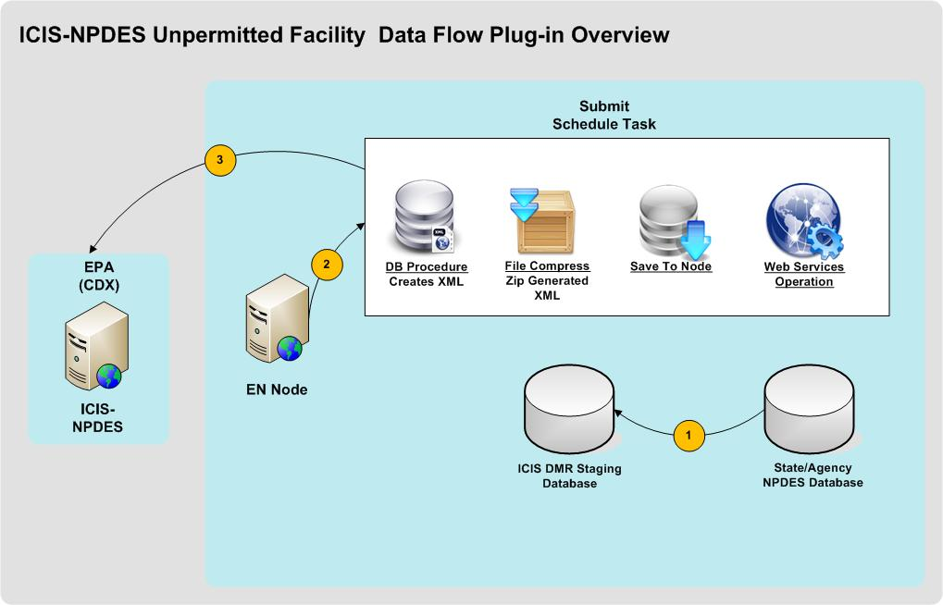

***Figure 1: ICIS-NPDES Unpermitted Facility Data Flow Plug-Ins Overview***

In the following sections and diagram below, the ICIS-NPDES Unpermitted Facility Plug-in is described in detail.



The State or Agency will populate the ICIS Staging Database.

The EN-Node Invokes the ICIS_Unpermited_Facility plug-in though Node Operation Manager. This process includes the following steps:

1. The plug-in obtains available ICIS-NPDES Unpermitted Facility data from the ICIS staging database.
2. The plug-in executes a Database stored procedure component to generate an ICIS-NPDES Unpermitted Facility XML file.

The plug-in then compresses the XML to a zip file, and submits the result to the EPA. The implementation details are described here:

1. The XML file generated during the previous step will be compressed and saved to the node database
2. An Authenticate web service call will then be invoked using the correct NAAS account information. The NAAS account information is part of the passing parameters to the plug-in.
3. If the Authenticate is successfully executed, a valid security token will be obtained. If the Authenticate fails, the process will end and the incident will be logged with a failed status in the EN-Node
4. The security token and the compressed file are delivered to the CDX via a web service Submit call.
5. The successful result of the submission is determined by obtaining the transaction id.
6. The transaction id will be saved and can be used to retrieve the data.

# Supported Schemas and Payloads

* Schema(s): 2.1
* Payload(s): Unpermitted FacilitySubmission

# Prerequisites

* EN-Node application is installed
* A local ICIS-NPDES data source exists in Oracle format

# Installation Package

* ICISNPDESStagingDB.zip
* DataWizardConfig_UnpermittedFacility.xml

# Installation Instruction



## Create a ICIS-NPDES Unpermitted Facility staging database

Before any ICIS-NPDES Unpermitted Facility plug-in installation, the user should make sure that the ICIS-NPDES staging database is created and stored in a directory. To do this, execute the following steps:

1. Log in to Oracle Server as an administrative account.
2. Find the ICISNPDESStagingDB.zip file and unzip it.
3. Open the file into Oracle Server.
4. Make sure to change the directory within the script to the desired database location before executing ICIS_STG_DB_STRUCTURE.sql.
5. Within the store procedure script ICIS_R_UNPERMITTEDFACILITY.sql, make sure to enter the necessary information for NAAS account. Please see screenshot below:

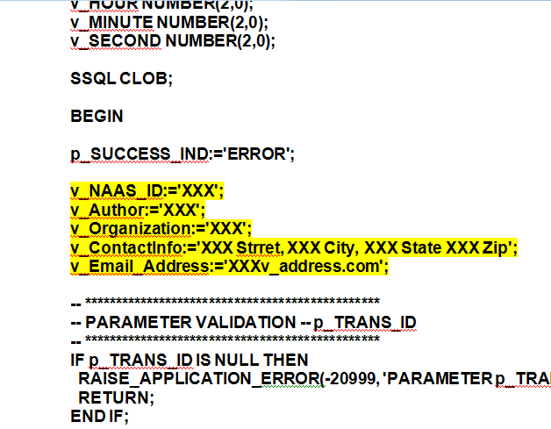

1. Execute all sql scripts contained within. Upon successful execution, the results will be as follows:

* ICIS-NPDES staging table will be created
* ICIS-NPDES stored procedures will be created

## Modify DataWizardConfig_UnpermitedFacility.xml

1. Before uploading the XML file, the user must make a few modifications within the script. These changes are as follows:

* The server information needs to be changed depending on the user’s specific server and server location in order to connect to ICIS-NPDES staging database.

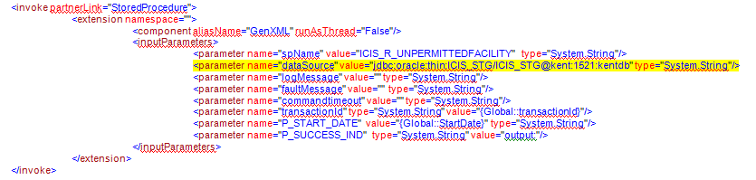

* The endpoint needs to be changed depending on the node version and whether this is in testing or production. The address for different endpoints within ICIS can be found at: <http://www.exchangenetworkwiki.com/wiki/index.php/Node_Endpoints_at_U.S._EPA%27s_Central_Data_Exchange>
* The account information (username and password) also need to be modified to fit the user’s account.

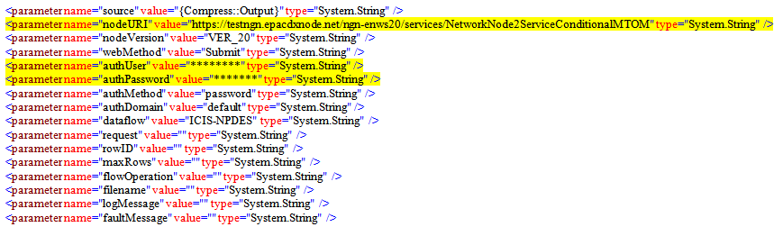

## Create a ICIS Domain in the Node Administration Console

In order to create an operation using ICIS-NPDES Unpermitted Facility plug-in under the EN-Node, the user must first create a Domain. The Domain is a logical grouping of operations, as described below:

1. Log into the Node.Administration console with the appropriate username and password.
2. Click the “New Domain” link under the “Node Domain” Module and fill in the following information:
   * **Domain Name:** ICIS
   * **Domain Administrator:** admin (or any other accounts you would like to manage the ICIS file creation process)
   * Check all “Allowed Web Services” check boxes
   * Click “Save” button

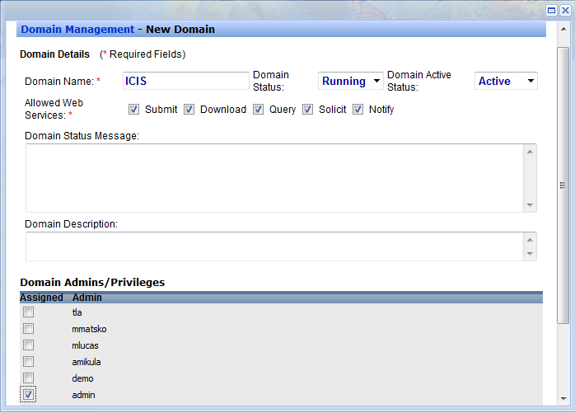

***Figure 2: New Domain Information***

## Create a submit web service with the ICIS_Unpermitted_Facility plug-in

1. Locate the “Node Domains” module from the Node Dashboard.
2. Under the “Node Domains” module, click the “Go to Operations” link for the ICIS Domain
3. Click the “Create Operation” button

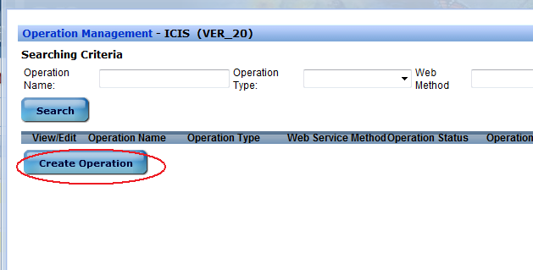

***Figure 3: Create New Operation***

1. Fill the form like below, click “Next” button

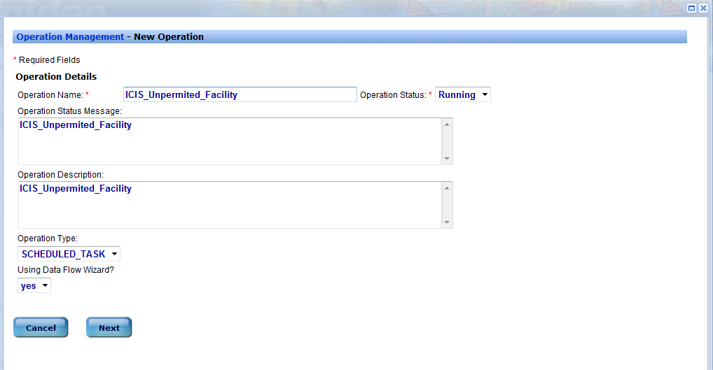

***Figure 4: Operation Configuration Page 1***

1. Click “Save” button

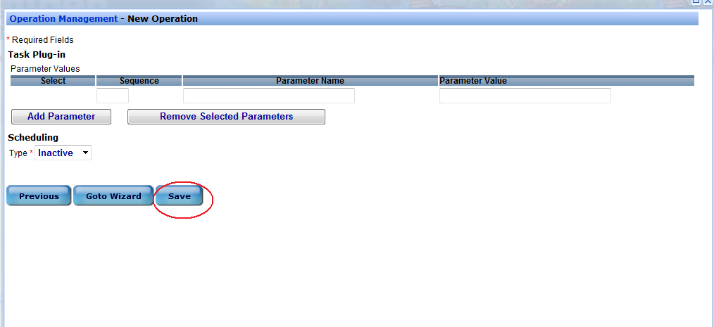

***Figure 5: Operation Configuration Page 2***

1. Go back to Dashboard and click “Data Wizard Configuration” link in “Node Configuration” module

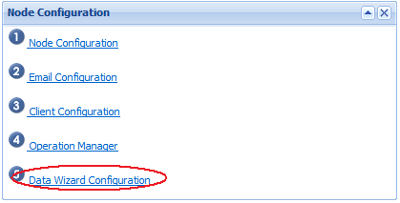

***Figure 6: Data Wizard Configuration***

1. Locate the operation and upload the DataWizardConfig_UnpermitedFacility.xml file.

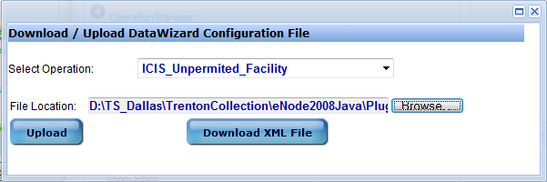

***Figure 7: Uploading Data Configuration File***

1. After the file is uploaded, the user should go to the task page to modify parameters and run the test. The below screenshot shows the page and an example of filled in parameters:

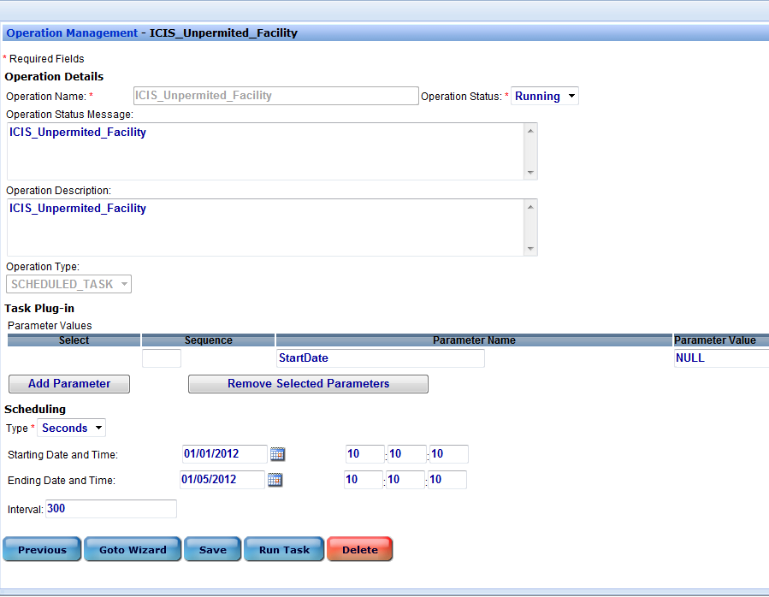

***Figure 8: Operation Configuration: Set Task Schedule and Modify Parameters***

1. Click Save

## Configure ICIS_Unpermitted_Facility plug-in for Operation Manager

1. Return to the Node Dashboard screen
2. Under the “Node Configuration” module, click the icon link for “Operation Manager”
3. Under the Operation Manager screen click the “Add Operation” button

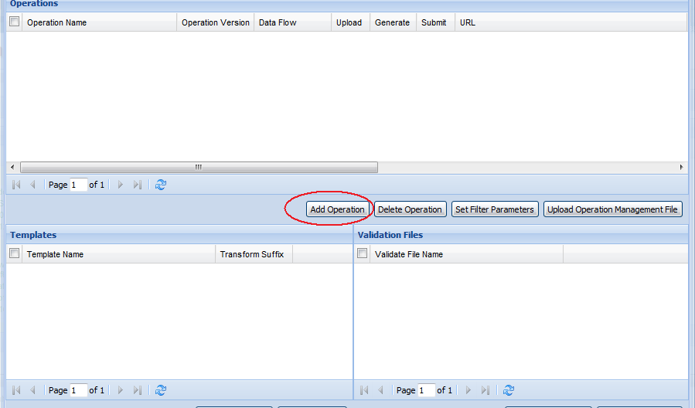

***Figure 9: Operation Manager: Add Operation***

1. Under the Configure Operation section:
   * Select Operation Name = ICIS_Unpermited_Facility
   * Operation Version = VER_20
   * Data Flow = ICIS-NPDES
   * Upload = False

Generate = True

Submit = True

* + Enter in URL as following:
    - 1. <https://testngn.epacdxnode.net/ngn-enws20/services/NetworkNode2ServiceConditionalMTOM>

for testing endpoint

* + - 1. <https://cdxnodengn.epa.gov/ngn-enws20/services/NetworkNode2ServiceConditionalMTOM>

for production endpoint

* + User Name = Enter NAAS assigned User ID
  + Password = Enter NAAS assigned Password
  + Domain Name = default
  + Get Status = True
  + Completed Status = Completed
  + Failed Status = Failed

1. Refer to Screenshot:

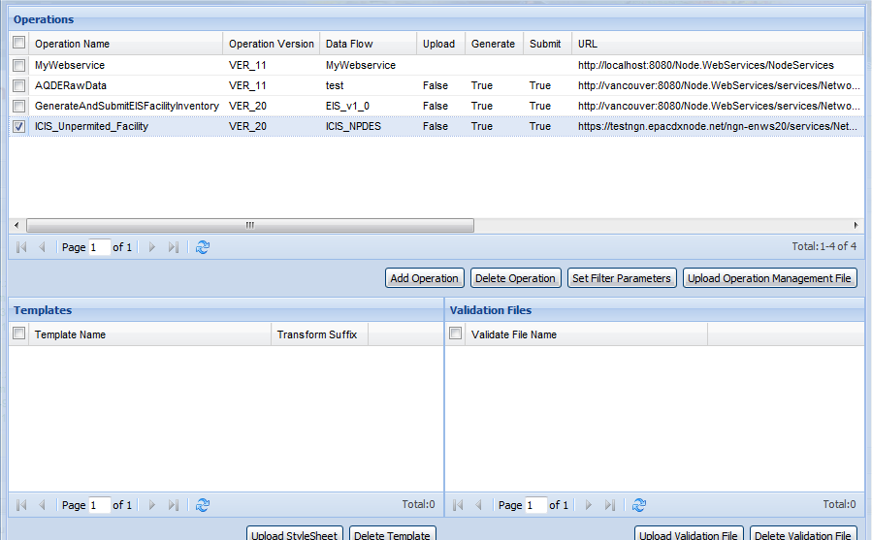

***Figure 10: Operation Manager: ICIS_Unpermitted_Facility***

# Test ICIS-NPDES Unpermitted Facility Plug-In

If the ICIS-NPDES staging database has been successfully populated by a local ICIS-NPDES data source from which the user will generate the ICIS-NPDES Unpermitted Facility XML files, the user can then generate the ICIS-NPDES Unpermitted Facility submission file from the ICIS-NPDES staging database and submit to EPA.



## Obtain Status and Supplied Transaction ID

* + - 1. Click on the “Node Operation Manager” link within the “Favorite Links” module in the dashboard

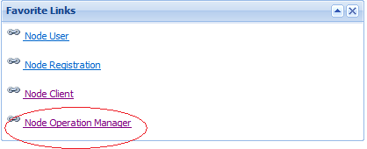

***Figure 11: Node Operation Manager***

* + - 1. Once in the Node Operation Manager, input the following information in the fields:
* Select “ICIS_Unpermited_Facility” under “Operation Name”
* Add “Start Date” or “End Date” if require
* Click Search

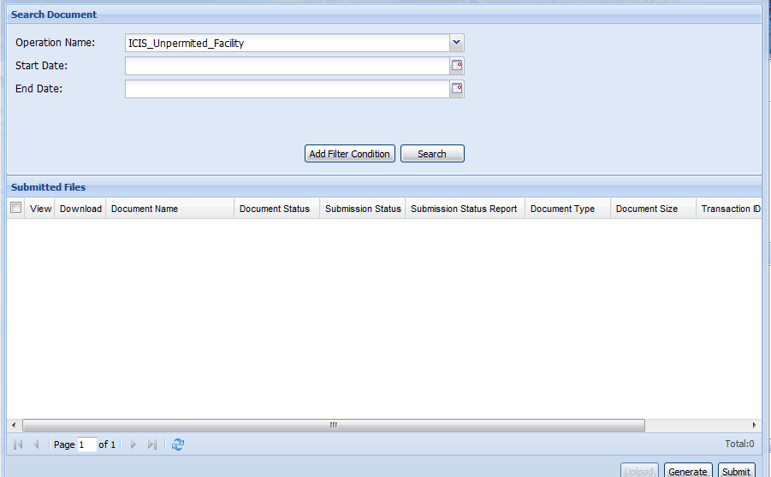

***Figure 12: Node Operation Manager Search Criteria***

* + - 1. The search should return a list of recent transactions including the Generated File, Submission Status, Transaction ID.

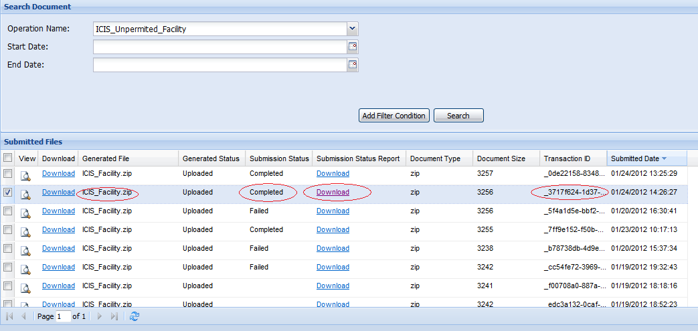

***Figure 13: Node Operation Manager: Operation Detail Table***

* + - 1. Click “Download” link to view the detail includes Operation Name, status, transaction ID, supplied transaction ID, and submission ID



***Figure 14: Node Operation Manager: Operation Status Report***

* + - 1. You can click “View” icon to download the result file which was from CDX, or you can follow next step to check file from Node client tool.

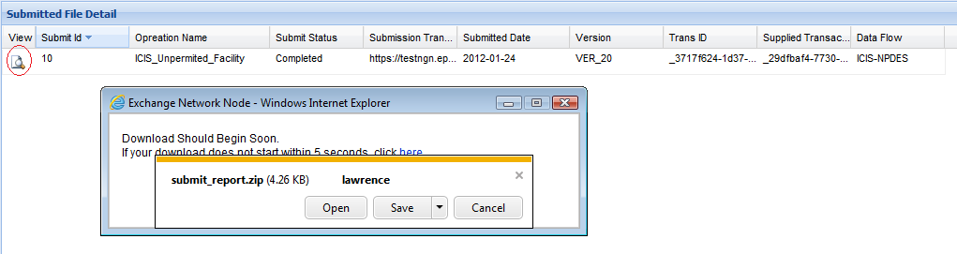

***Figure 15: Node Operation Manager: Downloading Result File***

* + - 1. Double click the “Supplied Transaction ID” field and Copy down it for future use.



***Figure 16: Node Operation Manager: Obtaining Transaction ID***

## Retrieving and Downloading file from Node Client

* + - 1. Go to the Node Client website at: <http://YourDomain:YourPort/Node.Client/Page/Entry/FrameSet.jsp>
      2. Click “Authenticate” from the menu on the left panel.
* Make sure the node version is node v2.
* Pick the destination Node Address from the dropdown list (in our case, we want to pick <https://testngn.epacdxnode.net/ngn-enws20/services/NetworkNode2ServiceConditionalMTOM>). If you don’t find it, please (

1. Go to dash board from Administration Link <http://YourDomain:YourPort/Node.Administration/Page/Entry/Login.do>
2. Click the “Client Configuration” link which is in “Node Configuration” module

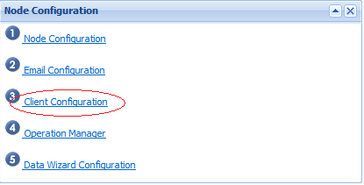

***Figure 17: Node Configuration***

1. Input the Node endpoint in the last box and click “Save” button

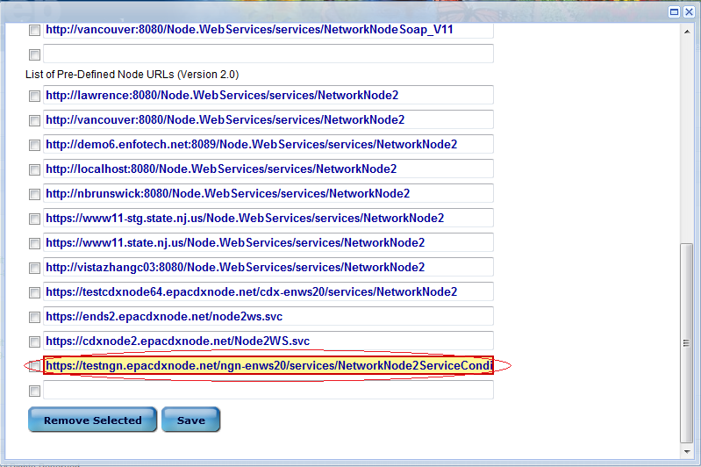

***Figure 18: Node Configuration: Setting Endpoints***

1. Go back to Step 1.)

* Complete the authentication process by entering the NAAS user name and password.
* Click “Authenticate”.
* Once the authentication is complete, the account will be validated and a security token is returned on the bottom of the page.

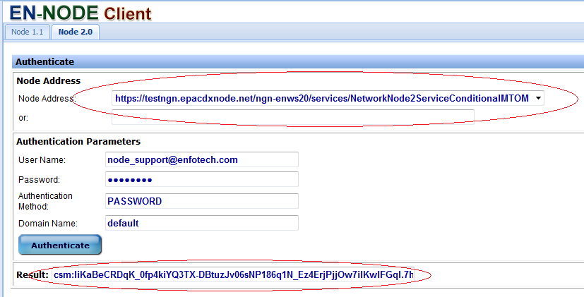

***Figure 19: Node Client: Authentication***

* + - 1. Click “GetStatus” from the menu on the left panel.
* Paste the Transaction ID that was copied in section 6.1.
* Click “GetStatus” button.
* The status should appear on the bottom of the page as either “Completed” or “Failed”. If the status is completed, the file is ready for download.

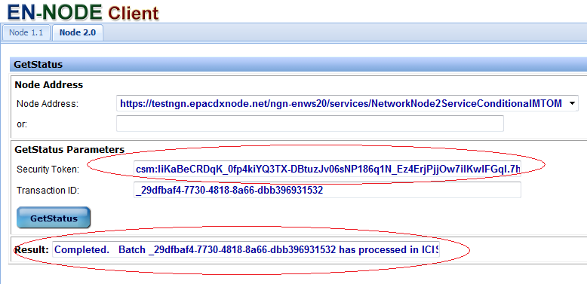

***Figure 20: Node Client: GetStatus***

* + - 1. Click “Download” from the menu on the left panel.
* Paste the Transaction ID that was copied in section 6.1.
* Enter Data Flow = ICIS-NPDES.
* Click “Download” button.
* The files should appear on the bottom of the page, ready to be downloaded.
* Click the file link to download file one by one.

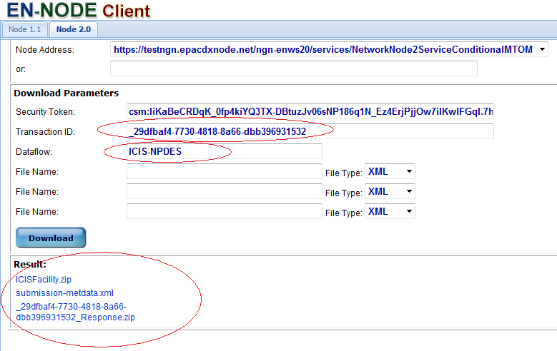

***Figure 21: Node Client: Download File***

* + - 1. The screenshots below will describe a few cases of the downloaded file. First, check the submission-metdata.xml to check whether or not the file has passed or failed the xml schema validation. If the schema has passed, the user should be able to download the retrieved data. If the schema has failed, the retrieved data will not appear under the download result.
* Passed Schema Validation:

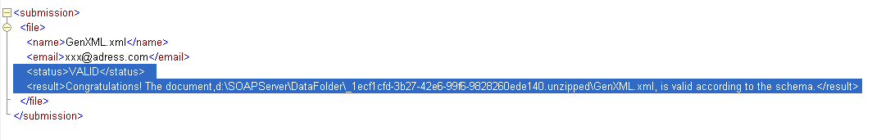

***Figure 22: Example: Passed Schema Validation***

* Failed Schema Validation:

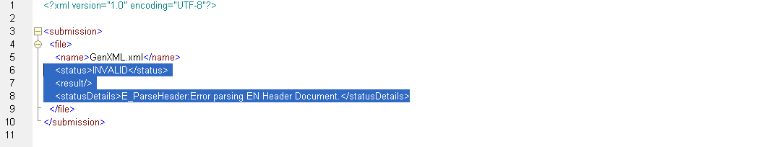

***Figure 23: Example: Failed Schema Validation***

* Passed Schema Validation, Error in Data:

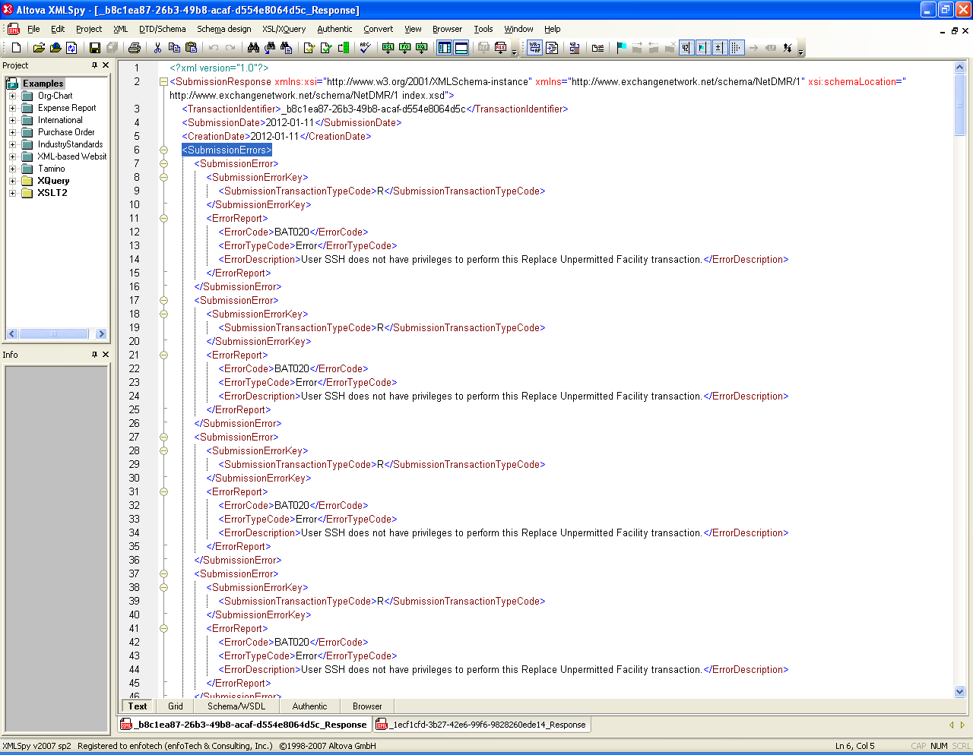

***Figure 24: Example: Passed Schema Validation, Data Error***

* Passed Schema Validation, No Error in Data:

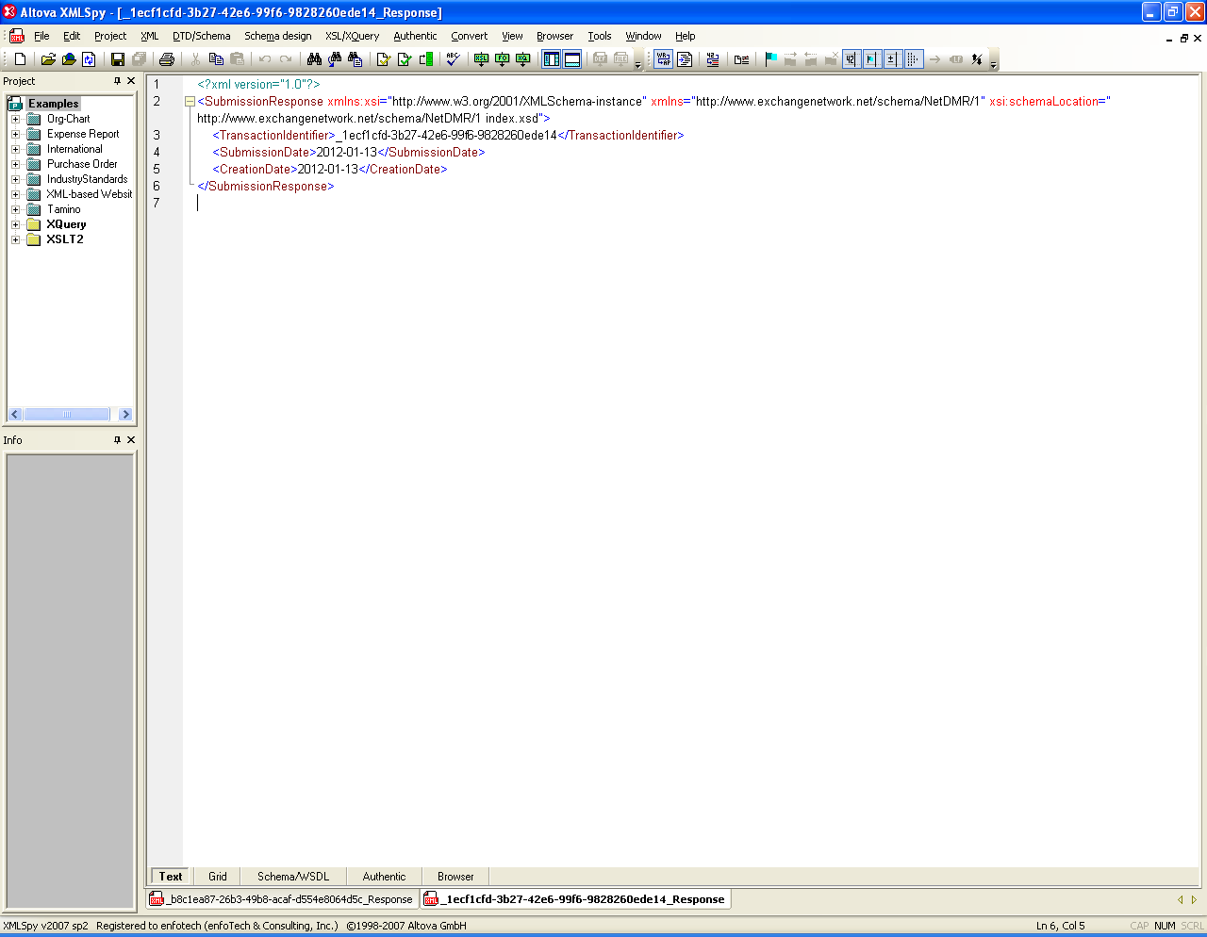

***Figure 25: Example: Passed Schema Validation, No Data Error***